1. Identification of Product
Product Identifier
Product Name: Fmoc-L-leucyl chloride
Product Code: CC10169
CAS Number: 103321-59-1
MFCD Number: MFCD00235818

Relevant Identified Uses of Substance or Mixture and Uses Advised Against
Research and Development use

Supplier Details of the Safety Data Sheet
Atlantic Research Chemicals Ltd, Unit A, Stratton View Business Park, Holsworthy Road, Bude, Cornwall EX23 9NR
Telephone: +44 (0)1288 355370 E-mail: info@atlantic-chemicals.com

2. Hazards Identification
Classification of the Substance or Mixture
Skin corrosion (Categories 1A, 1B, 1C)
Label Elements
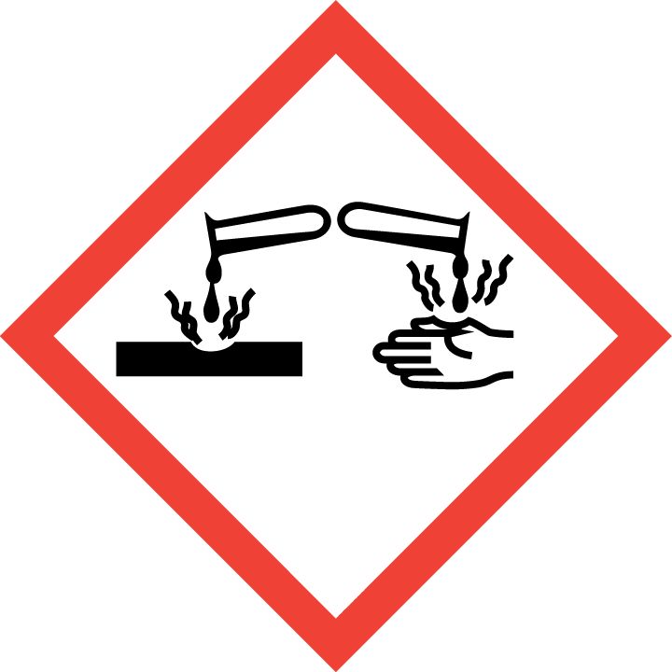

Signal Word: Danger.
Hazard Statements
H314 – Causes severe skin burns and eye damage.
Precautionary Statements
P280 Wear protective gloves/protective clothing/eye protection/face protection.
P301 + P330 + P331 IF SWALLOWED: rinse mouth. Do NOT induce vomiting.
P303 + P361 + P353 IF ON SKIN (or hair): Remove/Take off immediately all contaminated clothing. Rinse skin with water/shower.
P304 + P340 IF INHALED: Remove victim to fresh air and keep at rest in a position comfortable for breathing.
P305 + P351 + P338 IF IN EYES: Rinse cautiously with water for several minutes. Remove contact lenses, if present andeasy to do. Continue rinsing.
P501 Dispose of contents/container to local regulations
Other Hazards
No information available.

3. Composition/Information on Ingredients
Substances
Fmoc-L-leucyl chloride Assay: 95% CAS number: 103321-59-1
Mixtures
Concentration Product Name CAS number: EC/EINECS:

4. First Aid Measures
Description of First Aid Measures
Skin Contact IF ON SKIN: Wash with plenty of soap and water.
If skin irritation occurs: Get medical advice/attention.
Eye Contact If eye irritation persists: Get medical advice/attention.
IF IN EYES: Rinse cautiously with water for several minutes. Remove contact lenses, if present and easy to do so. Continue rinsing.
Ingestion IF SWALLOWED: Immediately call a POISON CENTRE or doctor/physician.
Inhalation IF INHALED: Remove victim to fresh air and keep at rest in a position comfortable for breathing.
Most Important Symptoms and Effects
There may be irritation and redness.
May cause permanent damage.
Indication of any Immediate Medical Attention
No additional measures required.

5. Fire Fighting Measures
Extinguishing Media
Suitable Carbon dioxide.
Dry chemical powder or foam.
Sand.
Unsuitable Water.
Special Hazards Arising from the Substance or mixture
In combustion toxic fumes may form.
Advice for Fire Fighters
Wear self-contained breathing apparatus.
Wear protective clothing to prevent contact with skin and eyes.

6. Accidental Released Measures
Personal Precautions
Do not attempt to take action without suitable protective clothing – see section 8 of SDS.
Do not create dust.
Evacuate the area immediately.
Environmental Precautions
Do not discharge into drains or rivers.
Contain the spillage using bunds.
Methods & Materials
Mix with sand or vermiculite.
Transfer to a closable, labelled salvage container for disposal by an appropriate method.

7. Handling and Storage
Personal Precautions
Safe Handling Ensure there is sufficient ventilation of the area.

Protection against Do not eat, drink or smoke when using this product.
explosions and fires Remove/take off immediately all contaminated clothing.
Take off contaminated clothing and wash before reuse.
Wash hands thoroughly after handling.
Conditions for Safe Storage, Including any Incompatibilities
Managing storage risks Store in a cool, well-ventilated area.
Keep container tightly closed.
Storage controls Do not store in conditions of high (or highly fluctuating) temperature.
Maintaining integrity Keep container tightly closed.
Other advice Store in a well-ventilated place.
Specific End Uses
The end use(s) have not been fully determined. The substance is supplied for Research and Development purposes by professionals only.

8. Exposure Controls/Personal Protection
Control Parameters
No data available
Exposure Controls
General protective and Wear protective gloves/protective clothing/eye protection/face protection.
hygiene measures Wash hands during breaks and at the end of handling the material.
Immediately remove any contaminated clothing.
Engineering measures Use only outdoors or in a well-ventilated area.
Eye/face protection Safety glasses with side shields.
Hand protection Protective gloves.
Respiratory protection Do not breathe dust/fumes/gas/vapours/spray.
Use breathing protection with high concentration.
Skin protection Handle with gloves.
Dispose of contaminated gloves after use in accordance with applicable laws and
good laboratory practice.
Wash and dry hands.
Protective clothing.
Other personal protection No data.
advice

9. Physical and Chemical Properties
Physical and Chemical Properties
Molecular formula: C21 H22 Cl N O3
Molecular weight: 371.862
Information on basic physical and chemical properties
a) Appearance: Solid
b) Odour: No data
c) Odour threshold: No data
d) pH: No data
e) Melting point/freezing point: 82 - 83°C
f) Initial boiling point and boiling range: No data
g) Flash point: No data
h) Evaporation rate: No data
i) Flammability (solid, gas): No data
j) Upper/lower flammability or explosive limits: No data
k) Vapour pressure: No data
l) Vapour density: No data
m) Relative density: No data
n) Water solubility: No data
o) Partition coefficient: n-octanol/ water: No data
p) Auto-ignition temperature: No data
q) Decomposition temperature: No data
r) Viscosity: No data
s) Explosive properties: No data
t) Oxidizing properties: No data
Other Information
No additional information.

10. Stability and Reactivity
Reactivity
No unusual reactivity.
Stability
Stable under normal conditions.
Possibility of Hazardous Reactions
No hazardous reactions known.
Conditions to avoid
Avoid moist atmosphere.
Incompatible Materials
Oxidising agents.
Water.
Strong bases.
Strong acids..
Hazardous Decomposition Products
In combustion emits toxic fumes.
In combustion emits toxic fumes of carbon dioxide / carbon monoxide.
In combustion emits toxic fumes of hydrogen bromide.
In combustion emits toxic fumes of hydrogen fluoride.
11. Toxicology Information
Information
Acute toxicity: No data
Skin corrosion/irritation: Causes burns to skin and mucous membranes
Serious eye damage: Causes burns
Respiratory or skin
sensitisation: No sensitising effect known
Germ cell mutagenicity: Not known
Carcinogenicity: Not known
Reproductive toxicity: Not known
Aspiration hazard: Not known
Additional
To the best of our knowledge the acute and chronic toxicity of this substance is not fully known. No classification data on carcinogenic properties of this material is available from the EPA, IARC, NTP, OSHA or ACGIH.

12. Ecological Information
Toxicity
Not known.
Persistence and Degradability
Not known.
Bio-Accumulative Potential
Not known.
Mobility in Soil
Not known.
Results of PBT & PvB Assessment
Not known.
Other Adverse Effects
Do not allow product to reach ground water, water bodies or sewage system, even in small quantities.

13. Exposure Controls/Personal Protection
Waste Treatment Methods
Disposal operations Offer surplus and non-recyclable solutions to a licensed disposal company. Dissolve
or mix the material with a combustible solvent and burn in a chemical incinerator
equipped with an afterburner and scrubber.
Disposal of packaging Disposal must be made according to official regulations.

14. Transport Information
Air (ICAO)
- UN Number: UN1759
- UN Proper shipping name: Corrosive solid, n.o.s.
- Transport hazard class(es): 8
- Packing group: III
- Environmental hazards: No
- Special precautions for user: For the purposes of documentation and package marking, the Proper
Shipping Name shall be supplemented with the technical name (see
3.1.2.8.1)
- Transport in bulk:
Road (ADR)
- UN Number: UN1759
- UN Proper shipping name: Corrosive solid, n.o.s
- Transport hazard class(es): 8
- Packing group: III
- Environmental hazards: No
- Special precautions for user: For the purposes of documentation and package marking, the Proper
Shipping Name shall be supplemented with the technical name (see
3.1.2.8.1)

- Transport in bulk:
Sea (IMDG)
- UN Number: UN1759
- UN Proper shipping name: Corrosive solid, n.o.s
- Transport hazard class(es): 8
- Packing group: III
- Environmental hazards: No
- Special precautions for user: For the purposes of documentation and package marking, the Proper
Shipping Name shall be supplemented with the technical name (see
3.1.2.8.1)
Transport in bulk: IBCINS: IBC02
UNTANKINS: T11
TANKPROV: TP2 TP27

15. Safety, Health and Environmental Regulations
Safety, Health and Environmental Regulations:
Product is not subject to any additional regulations.
Safety Assessment
No chemical Safety Assessment

16. Other Information
ADR: Accord Europeen sur le transport des merchandises Dangereuses par Route (European Agreement concerning the International Carriage of Dangerous Goods by Road)
RID: Reglement International concernant le transport des merchandises dangereuses par chemin de fer (Regulations concerning the International transport of Dangerous Goods by Rail)
IMDG: International Maritime Code for Dangerous Goods
IATA: International Air Transport Association
IATA-DGR: Dangerous Goods Regulations by the International Air Transport Association
ICAO: International Civil Aviation Organisation
ICAO-TI: Technical Instructions by the ICAO
GHS: Globally Harmonized System of Classification and Labelling of Chemicals
CAS: Chemical Abstracts Service
Associated Risk Phrases According to European Directives 67/548/EEC

R34 | Causes burns

Disclaimer
The product is listed for research and development purposes only and not for human or animal use. As such, in most cases, the toxicological, ecological and physicochemical properties have not been fully determined and the product should be treated with respect and always handled under suitable conditions by appropriately qualified personnel. The responsible party shall use this datasheet only in conjunction with other sources of information gathered by them, and should make an independent judgement of suitability, to ensure proper use and protect the health and safety of employees. This information is furnished without warranty and any use of the product not in conformance with this safety data sheet, or in combination with any other product or process is the responsibility of the user.

Certified by: J A Forshaw

