1. Identification of Product
Product Identifier
Product Name: 4-Methylthio-3-trifluoromethylphenylisocyanate
Product Code: IC00152
CAS Number: 61386-59-2
MFCD Number: MFCD31009206

Relevant Identified Uses of Substance or Mixture and Uses Advised Against
Research and Development use

Supplier Details of the Safety Data Sheet
Atlantic Research Chemicals Ltd, Unit A, Stratton View Business Park, Holsworthy Road, Bude, Cornwall EX23 9NR
Telephone: +44 (0)1288 355370 E-mail: info@atlantic-chemicals.com

2. Hazards Identification
Classification of the Substance or Mixture
Acute toxicity, oral (category 3)
Acute toxicity, dermal (category 3)
Acute toxicity, inhalation (category 2)
Respiratory sensitisation (category 1)
Skin sensitisation (category 1)
Skin irritation (category 2)
Eye irritation (category 2)
STOT single exposure (category 3)
Label Elements
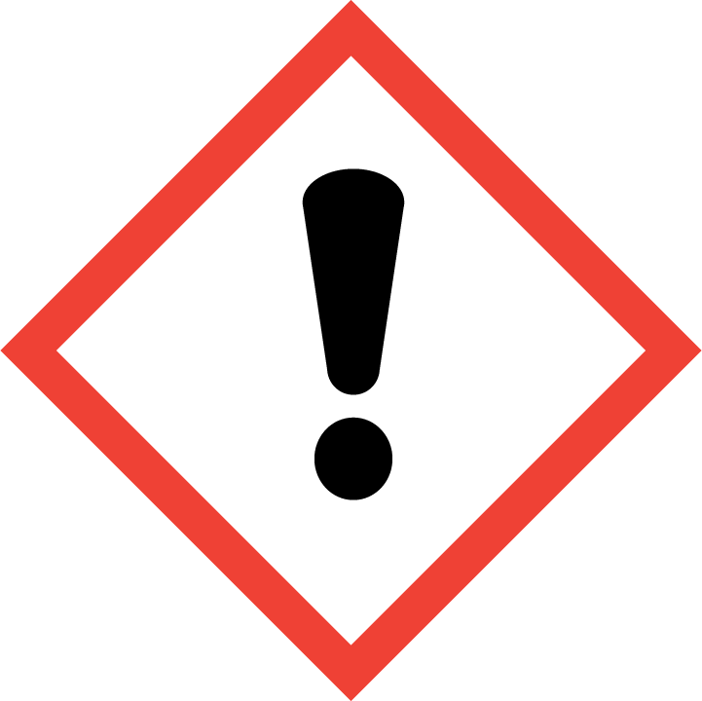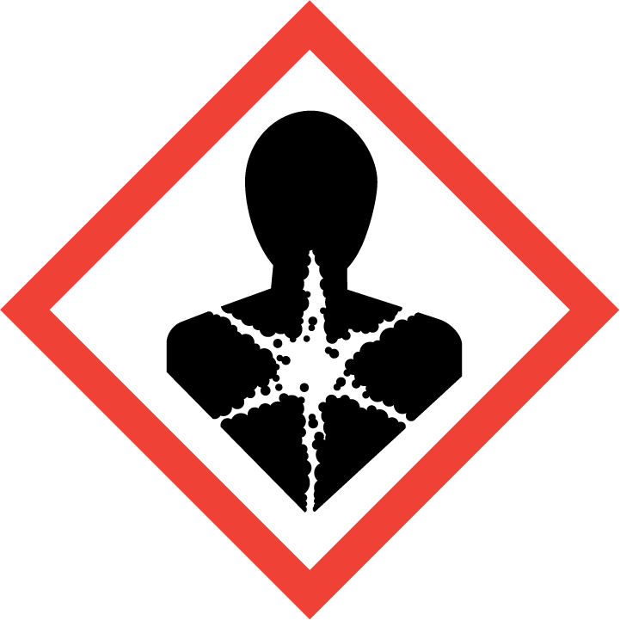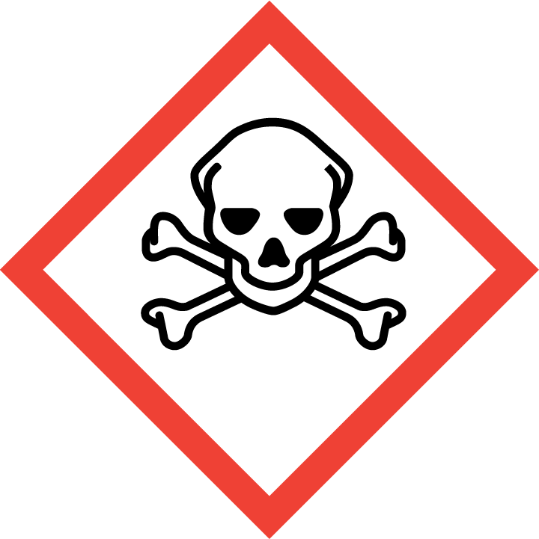

Signal Word: Warning
Hazard Statements
H301 - Toxic if swallowed.
H311 - Toxic in contact with skin.
H330 - Fatal if inhaled.
H315 - Causes skin irritation.
H317 - May cause an allergic skin reaction.
H319 - Causes serious eye irritation.
H334 - May cause allergy or asthma symptoms or breathing difficulties if inhaled.
H335 - May cause respiratory irritation.
Precautionary Statements
P260 – Do not breathe dust/fumes/gas/mist/vapours/spray.
P280 – Wear protective gloves/protective clothing/eye protection/face protection.
P301 + P310 - IF SWALLOWED: Immediately call a POISON CENTER or doctor/ physician.
P302 + P352 – IF ON SKIN: Wash with plenty of soap and water.
P304 + P340 – IF INHALED: Remove victim to fresh air and keep at rest in a position comfortable for breathing.
P305 + P351 + P338 – IF IN EYES: Rinse cautiously with water for several minutes. Remove contact lenses, if present and easy to do, continue rinsing.
Other Hazards
Lachrymator (substance which increases the flow of tears).

3. Composition/Information on Ingredients
Substances
4-Methylthio-3-trifluoromethylphenylisocyanate Assay: 95% CAS number: 61386-59-2

Concentration Product Name CAS number: EC/EINECS:

4. First Aid Measures
Description of First Aid Measures
Skin Contact IF ON SKIN: Wash with plenty of soap and water.
If skin irritation occurs: Get medical advice/attention.
Eye Contact If eye irritation persists: Get medical advice/attention.
IF IN EYES: Rinse cautiously with water for several minutes. Remove contact lenses, if present and easy to do so. Continue rinsing.
Ingestion IF SWALLOWED: Immediately call a POISON CENTRE or doctor/physician. Do not induce
vomiting.
Inhalation IF INHALED: Remove victim to fresh air and keep at rest in a position comfortable for breathing.
Most Important Symptoms and Effects
No data.
Treat symptomatically.
Indication of any Immediate Medical Attention
No additional measures required.

5. Fire Fighting Measures
Extinguishing Media
Suitable Carbon dioxide.
Dry chemical powder or foam.
Sand.
Unsuitable Water.
Special Hazards Arising from the Substance or mixture
In combustion emits carbon oxides, nitrogen oxides and hydrogen chloride.
Advice for Fire Fighters
Wear self-contained breathing apparatus.
Wear protective clothing to prevent contact with skin and eyes.

6. Accidental Released Measures
Personal Precautions
Do not attempt to take action without suitable protective clothing – see section 8 of SDS.
Do not create dust.
Evacuate the area immediately.
Environmental Precautions
Do not discharge into drains or rivers.
Contain spillage with bunds.
Methods & Materials
Mix with sand or vermiculite.
Transfer to a closable, labelled salvage container for disposal by an appropriate method.

7. Handling and Storage
Personal Precautions
Safe Handling Ensure there is sufficient ventilation of the area.
Protection against Do not eat, drink or smoke when using this product.
explosions and fires Remove/take off immediately all contaminated clothing.
Take off contaminated clothing and wash before reuse.
Wash hands thoroughly after handling.
Conditions for Safe Storage, Including any Incompatibilities
Managing storage risks Store in a cool, well-ventilated area.
Keep container tightly closed.
Storage controls Do not store in conditions of high (or highly fluctuating) temperature.
Store away from water.
Store away from oxidising agents.
Maintaining integrity Keep container tightly closed.
Moisture sensitive - keep dry.
Store under an inert atmosphere.
Other advice Store in a well-ventilated place.
Specific End Uses
The end use(s) have not been fully determined. The substance is supplied for Research and Development purposes by professionals only.

8. Exposure Controls/Personal Protection
Control Parameters
This product, as supplied, does not contain any hazardous materials with occupational exposure limits established by the region specific regulatory bodies.
Exposure Controls
General protective and Wear protective gloves/protective clothing/eye protection/face protection.
hygiene measures Wash hands during breaks and at the end of handling the material.
Immediately remove any contaminated clothing.
Engineering measures Use only outdoors or in a well-ventilated area.
Eye/face protection Safety glasses with side shields.
Hand protection Protective gloves.
Respiratory protection Do not breathe dust/fumes/gas/vapours/spray.
Use breathing protection with high concentration.
Skin protection Handle with gloves.
Dispose of contaminated gloves after use in accordance with applicable laws and
good laboratory practice.
Wash and dry hands.
Protective clothing.
Other personal protection No data.
advice

9. Physical and Chemical Properties
Physical and Chemical Properties
Molecular formula: C9 H6 F3 N O S
Molecular weight: 233.212
Information on basic physical and chemical properties
a) Appearance: Off-white solid
b) Odour: No data
c) Odour threshold: No data
d) pH: No data
e) Melting point/freezing point: 27-29 °C
f) Initial boiling point and boiling range: No data
g) Flash point: No data
h) Evaporation rate: No data
i) Flammability (solid, gas): No data
j) Upper/lower flammability or explosive limits: No data
k) Vapour pressure: No data
l) Vapour density: No data
m) Relative density: No data
n) Water solubility: Hydrolyses
o) Partition coefficient: n-octanol/ water: No data
p) Auto-ignition temperature: No data
q) Decomposition temperature: No data
r) Viscosity: No data
s) Explosive properties: Product is not explosive
t) Oxidizing properties: No data

Other Information
No additional information.

10. Stability and Reactivity
Reactivity
No unusual reactivity.
Stability
Stable under normal conditions.
Possibility of Hazardous Reactions
No hazardous reactions known.
Conditions to avoid
Do not expose material to any source of ignition.
Excessive heat.
Avoid moist atmosphere.
Incompatible Materials
Strong oxidizing agents.
Water.
Bases.
Alcohols.
Amines.
Hazardous Decomposition Products
In combustion emits carbon oxides, nitrogen oxides and hydrogen chloride.

11. Toxicology Information
Information
Acute toxicity: Fatal if inhaled.
Skin corrosion/irritation: Causes skin irritation.
Serious eye damage: Causes serious eye irritation.
Respiratory or skin
sensitisation: May cause sensitisation by inhalation and skin contact.
Germ cell mutagenicity: Not known.
Carcinogenicity: There are no known carcinogenic chemicals in this product.
Reproductive toxicity: Not known.
Aspiration hazard: Not known.
Additional
To the best of our knowledge the acute and chronic toxicity of this substance is not fully known. No classification data on carcinogenic properties of this material is available from the EPA, IARC, NTP, OSHA or ACGIH.

12. Ecological Information
Toxicity
Not known.
Persistence and Degradability
Not known.
Bio-Accumulative Potential
Not known.
Mobility in Soil
Not known.
Results of PBT & PvB Assessment
Not known.
Other Adverse Effects
Water hazard class 1 (self-assessment): slightly hazardous for water. Do not allow product to reach ground water, water bodies or sewage system, even in small quantities.

13. Exposure Controls/Personal Protection
Waste Treatment Methods
Disposal operations Offer surplus and non-recyclable solutions to a licensed disposal company. Dissolve
or mix the material with a combustible solvent and burn in a chemical incinerator
equipped with an afterburner and scrubber.
Disposal of packaging Disposal must be made according to official regulations.

14. Transport Information
Air (ICAO)
- UN Number: UN2250
- UN Proper shipping name: Diclorophenyl Isocyantes
- Transport hazard class(es): 6.1
- Packing group: II
- Environmental hazards: No
- Special precautions for user: Warning: toxic substances.
7. Transport in bulk: Not applicable.

Road (ADR)
- UN Number: UN2250
- UN Proper shipping name: Diclorophenyl Isocyantes
- Transport hazard class(es): 6.1 (T2) toxic substances.
- Packing group: II
- Environmental hazards: No
- Special precautions for user: Warning: toxic substances.
7. Transport in bulk: Excepted quantities (EQ): E4
Limited quantities (LQ): 500 g
Transport category: 2
Tunnel restriction code: D/E
Sea (IMDG)
- UN Number: UN2250
- UN Proper shipping name: Diclorophenyl Isocyantes
- Transport hazard class(es): 6.1
- Packing group: II
- Environmental hazards: Marine pollutant: no.
- Special precautions for user: Warning: Toxic substances.
7. Transport in bulk: Not applicable.

15. Safety, Health and Environmental Regulations
Safety, Health and Environmental Regulations:
Product is not subject to any additional regulations.
Safety Assessment
No chemical Safety Assessment

16. Other Information
ADR: Accord Europeen sur le transport des merchandises Dangereuses par Route (European Agreement concerning the International Carriage of Dangerous Goods by Road)
RID: Reglement International concernant le transport des merchandises dangereuses par chemin de fer (Regulations concerning the International transport of Dangerous Goods by Rail)
IMDG: International Maritime Code for Dangerous Goods
IATA: International Air Transport Association
IATA-DGR: Dangerous Goods Regulations by the International Air Transport Association
ICAO: International Civil Aviation Organisation
ICAO-TI: Technical Instructions by the ICAO
GHS: Globally Harmonized System of Classification and Labelling of Chemicals
CAS: Chemical Abstracts Service
Associated Risk Phrases According to European Directives 67/548/EEC

R23/24/25 | Toxic by inhalation, in contact with skin and if swallowed
R36/37/38 | Irritant to eyes, respiratory system and skin
R42/43 | May cause sensitisation by inhalation and skin contact

Disclaimer
The product is listed for research and development purposes only and not for human or animal use. As such, in most cases, the toxicological, ecological and physicochemical properties have not been fully determined and the product should be treated with respect and always handled under suitable conditions by appropriately qualified personnel. The responsible party shall use this datasheet only in conjunction with other sources of information gathered by them, and should make an independent judgement of suitability, to ensure proper use and protect the health and safety of employees. This information is furnished without warranty and any use of the product not in conformance with this safety data sheet, or in combination with any other product or process is the responsibility of the user.

Certified by: J A Forshaw

